**EXPERIMENT 1.2**

**Aim :**

Implementation of Simple Neural Network (McCulloh-Pitts model)

**Theory :**

Every neuron model consists of a processing element with synaptic input connection and a single input. The "neurons" operated under the following assumptions:-

1. They are binary devices (Vi = [0,1])
2. Each neuron has a fixed threshold, theta values.
3. The neuron receives inputs from excitatory synapses, all having identical weights.
4. Inhibitory inputs have an absolute veto power over any excitatory inputs.

XOR gate or exclusive or gate gives a true output when the number of true inputs is odd. If both the inputs are true and both are false then the output is false. These are used to implement binary addition in computers. The truth table and symbol are shown below.

|  |  |  |
| --- | --- | --- |
| X1 | X2 | Y |
| 0 | 0 | 0 |
| 0 | 1 | 1 |
| 1 | 0 | 1 |
| 1 | 1 | 0 |

McCulloch and Pitts drew on three sources:

Knowledge of the basic physiology and function of neurons in the brain;

The formal analysis of propositional logic due to Russell and Whitehead;

Turing's theory of computation.

They proposed a model of artificial neurons in which each neuron is characterized as being "on" or "off," with a switch to "on" occurring in response to stimulation by a sufficient number of neighbouring neurons.

The state of a neuron was conceived of as "factually equivalent to a proposition which proposed its adequate stimulus." They showed, for example, that any computable function could be computed by some network of connected neurons, and that all the logical connectives could be implemented by simple net structures.

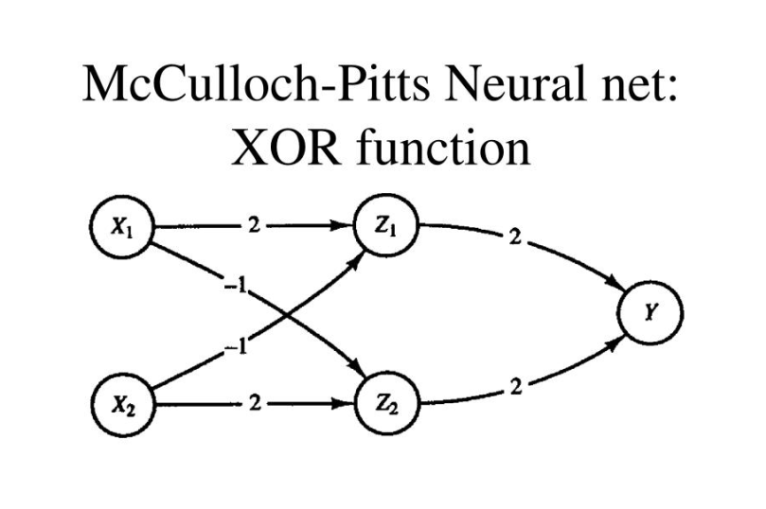

**Code:**

x1 = [0 0 1 1];

x2 = [0 1 0 1];

z = [0 1 1 0];

disp('Enter Weights:');

w11= input('Weight w11:');

w12= input('Weight w12:');

w21= input('Weight w21:');

w22= input('Weight w22:');

v1= input('Weight v1:');

v2= input('Weight v2:');

theta=input('Enter threshold value, theta: ');

y=[0 0 0 0];

y1=[0 0 0 0];

y2=[0 0 0 0];

con=1;

while con

zin1=x1*w11+x2*w12;

zin2=x1*w21+x2*w22;

for i=1:4

if zin1(i) >=theta

y1(i)=1;

else

y1(i)=0;

end

if zin2(i) >=theta

y2(i)=1;

else

y2(i)=0;

end

end

yin=y1*v1+y2*v2;

for i=1:4

if yin(i) >=theta

y(i)=1;

else

y(i)=0;

end

end

fprintf('\nOutput of Net:');

disp(y);

if isequal(y, z)

con=0;

else

disp('Net is not learing. Enter another set of weight and threshold value.');

w11= input('Weight w11:');

w12= input('Weight w12:');

w21= input('Weight w21:');

w22= input('Weight w22:');

v1= input('Weight v1:');

v2= input('Weight v2:');

theta=input('Enter threshold value, theta: ');

end

end

disp('McCulloch Pitts net for XOR function: ');

fprintf('\nWeight of Neuron Z1:');

disp([w11,w12]);

fprintf('Weight of Neuron Z2:');

disp([w21,w22]);

fprintf('Weight of Neuron Y:');

disp([v1,v2]);

fprintf('Threshold value:');

disp(theta);

**Output:**

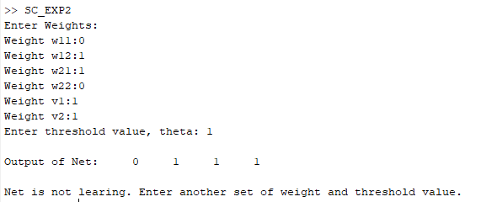

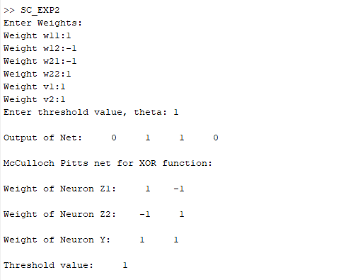

**Learning Outcomes:**

1. I learnt about the XOR gate implementation in matlab.
2. I learnt about the McCulloh-Pitts model.
3. I learnt about the basics such as threshold frequency, theta values and neurons etc.
4. I learnt about the basics of Neural network.
5. I learnt about how to develop intelligent learning system using McCulloh-Pitts model.